CC
LAB – 5
NAME – ANKUR SHARMA
SRN – PES2UG23CS077

SS1:
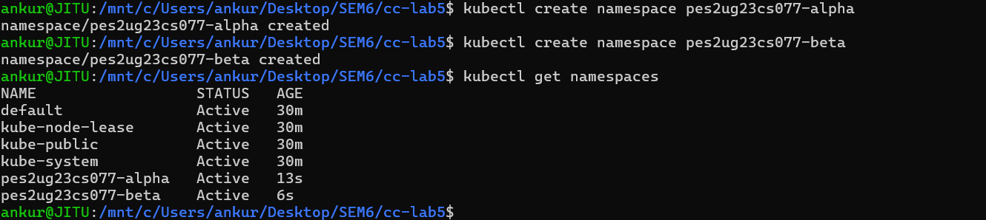
SS2:
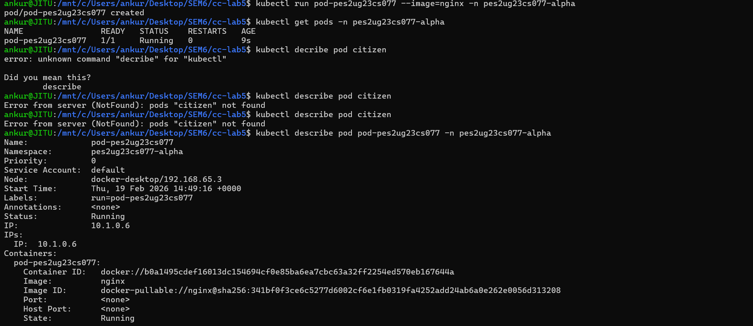
SS3:
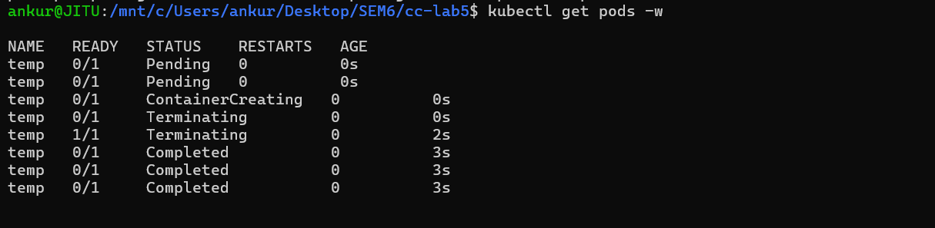

SS4:
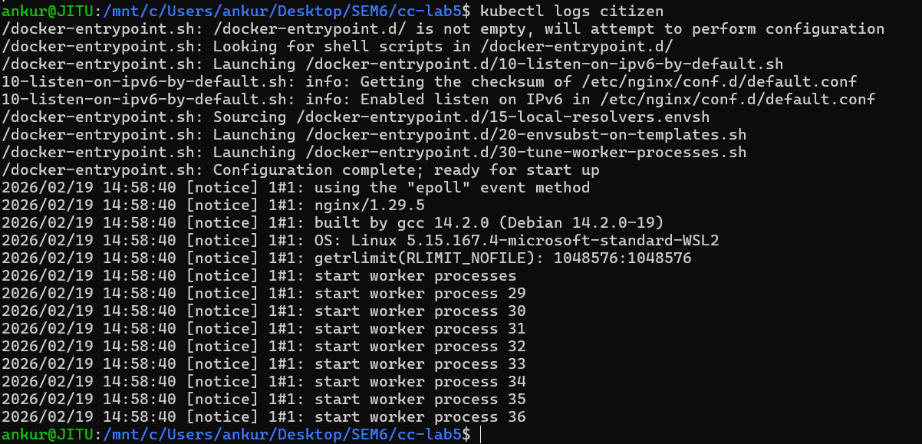
SS5:
SS6:
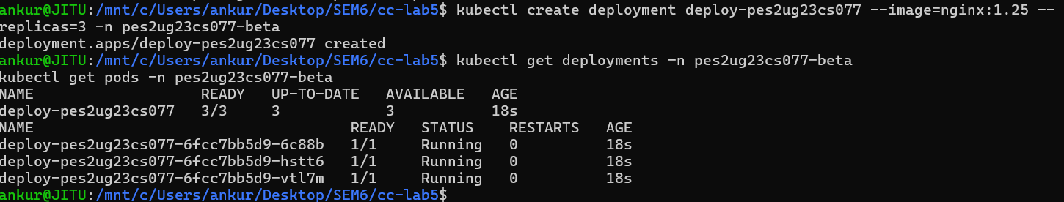
SS7:
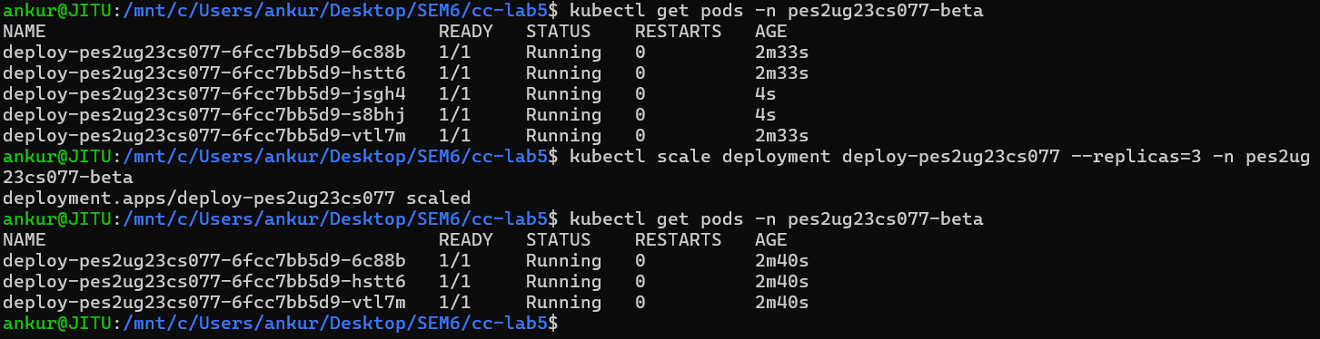

SS8:
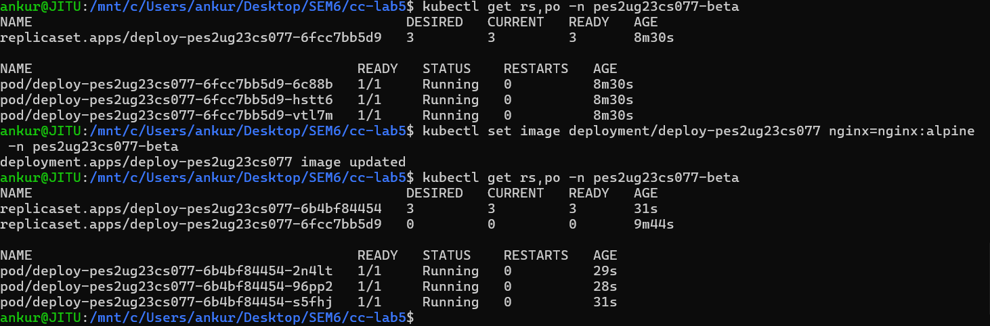
SS9:
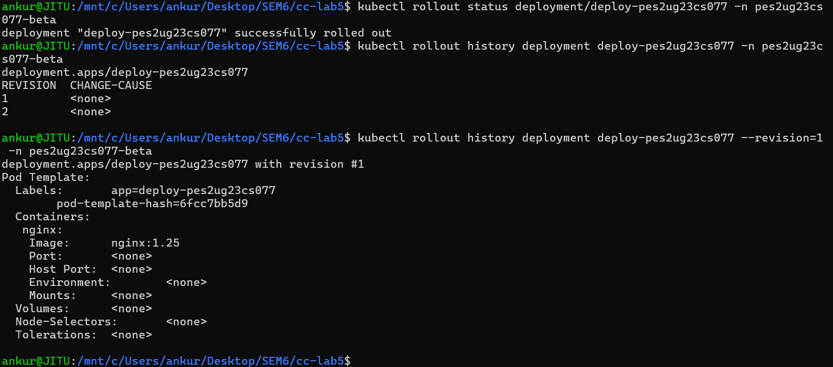
SS10:

SS11:
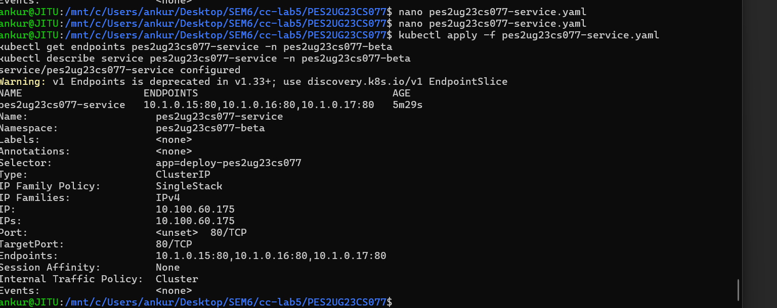
SS12:
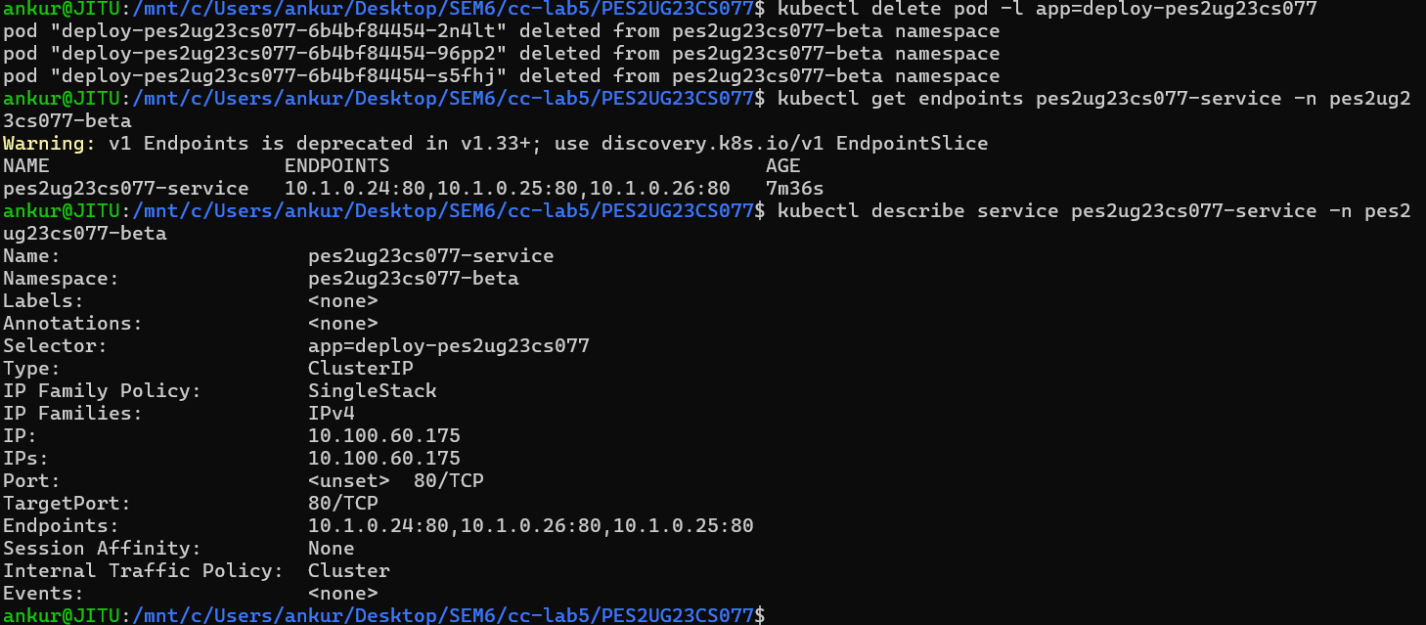
SS13:

SS14:
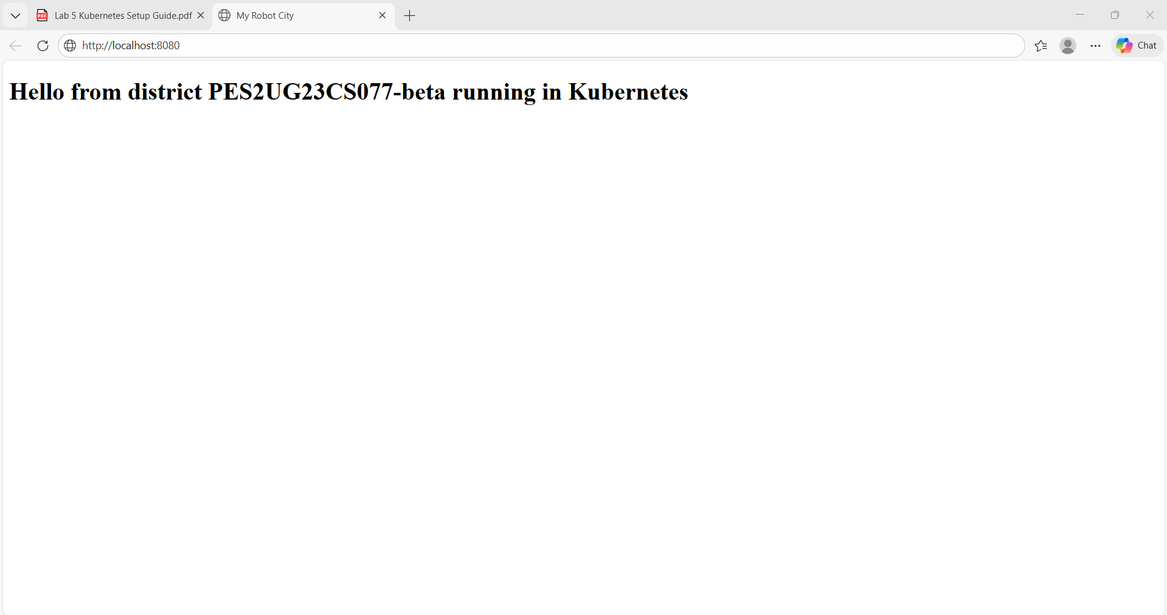
SS15:
